Life on the Reservations
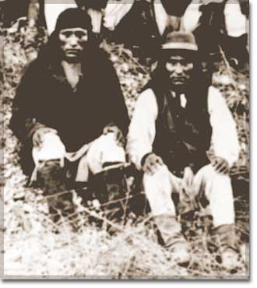
After being forced off their native lands, many American Indians found life to be very difficult. Beginning in the first half of the 19th century certain tribes were confined to small areas to live and continue their traditional ways of life.

Nomadic tribes used to hunting over miles and miles of land lost their means of getting food by being limited to a small area. Farmers found themselves with land unsuitable for farming. Many didn’t know how to make irrigation (watering) systems. Tribes were often forced to live near rival tribes. This often resulted in wars.

The Dawes Act
Faced with disease, alcoholism, and despair on the reservations, government officials passed the Dawes Severalty Act of 1887. Each Native American family was offered 160 acres of tribal land to own outright. The goal of the Dawes Act was to get Native Americans to live like white Americans. Reservations were broken up into "allotments" that were given out to individual families. Families were supposed to farm and build homes on their allotment to support themselves. Land that wasn't given to a Native American family was sold by the US government to white farmers and railroad companies. The proceeds were used to set up schools to teach the reading and writing of English. In an attempt to “Americanize” Native American children, they were required to attend the reservation school and sometimes change their names to “American” names.

The Dawes Act failed for several reasons. Some of the land was unsuitable for farming and ranching.
Some Native Americans refused to adopt a different way of life. Some sold their land to white settlers, but others were upset that their land was given away.

Destroying the Bison
Bison ("buffalo") were the main source of food and clothing for Native Americans on the Great Plains.
The US army, railroad companies and white settlers systematically set out to kill all bison.

The Dawes Act was a disaster for tribal units. In 1900, land held by Native American tribes was half that of 1880. When the Dawes Act was repealed in 1934, alcoholism, poverty, illiteracy, and suicide rates were higher for Native Americans than any other ethnic group in the United States.

