In 1476, Christopher Columbus, an Italian, found himself living in Portugal. Everything about this center for explorers heated this adventurous young man's desire to find new and unknown lands. During his years in Portugal he mastered the art of navigation. He read about the journeys of Marco Polo, who had voyaged to strange lands as far away as Asia. Polo's story of his journey to Cathay (China) in 1275 described a land rich in spices, jewels, and silks.
Christopher Columbus tried for nearly ten years to interest European rulers in his plan to find a new route to Asia. Some agreed that Asia lay to the west. He miscalculated the distance, however, because he estimated that the earth was smaller than it really is.

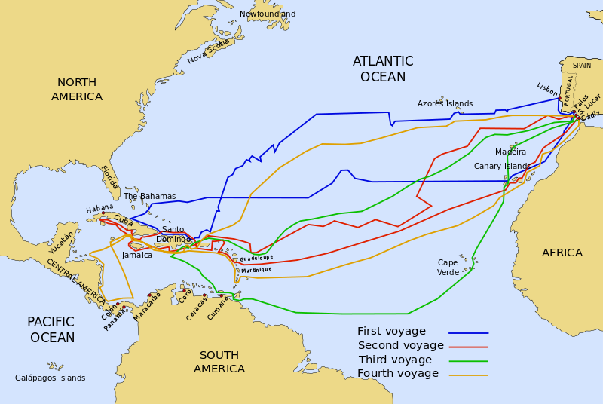
Columbus' First Voyage to the New World
Finally, in 1492, King Ferdinand and Queen Isabella, the rulers of the Spanish kingdoms of Castile and Aragon, agreed to outfit three ships for Columbus. They promised to make him viceroy (governor) of any new lands he might acquire. And they offered him 10 percent of all the wealth that he would bring to Spain.
With his fleet of three ships — the Niña, the Pinta, and the Santa María — Columbus sailed west on August 3, 1492. A crew of about ninety men manned the ships. Columbus kept a careful log of his voyage. After stopping at the Canary Islands to make repairs and take aboard fresh food, the fleet headed out into the open Atlantic — the Sea of Darkness.

As the days passed, tension mounted in the crew. None had ever been out of sight of land for so long. The wind blew steadily from the northeast. They wondered whether they would be able to sail against it to return home.
Nevertheless, rumbles of mutiny swept through the crew as Columbus pressed on. On the 70th day (many days after Columbus had already expected to reach Japan), a lookout sighted land. It was early on the morning of October 12, 1492. They landed on one of the islands of the Bahamas, which Columbus named San Salvador. The island natives came down to the shore to see Columbus' strange ships. Thinking he had reached the East Indies, Columbus called these people Indians.
Columbus had discovered what Europeans would soon call the New World of the Americas. Of course, it was not a New World to the millions of Native Americans already living there. They had been there thousands of years before the Europeans would "discover" them.

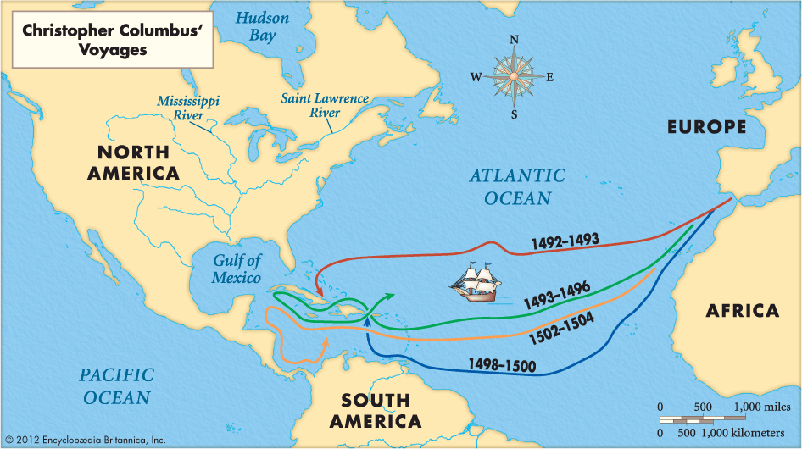
During four separate trips that started with the one in 1492, Columbus landed on various Caribbean islands that are now the Bahamas as well as the island later called Hispaniola. He also explored the Central and South American coasts. But he didn’t reach North America, which, of course, was already inhabited by Native Americans, and he never thought he had found a new continent.

