Myth Toons
Hi, these are my Myth Toons and they are my favorites. I enjoy drawing them and I hope you do too.
This is the three way crash:
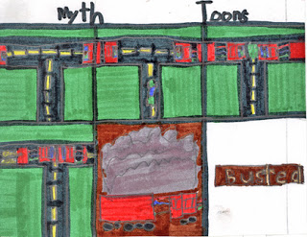
There are two trucks accidentally driving on the same side of the road and then, a European compact drives into the T at just the wrong time because it got smashed into a pancake and when they tried to take it apart they couldn't because they were fused together, so they had to take it to the junkyard that way.
This is a man on a motorcycle and he is driving at one hundred miles per hour in Africa and a Goliath beetle hit him in the chest and he fell to the ground, dead.
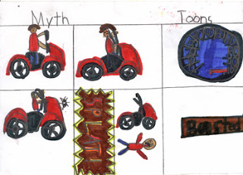
This is a Lego ball and the team need to have lots of help and even then it took weeks. When it was done they rolled it downhill and and with each roll hundreds of Legos fell off, half way through it broke in half and then it fell apart. It never had made it to the finish line.
Here's one more:
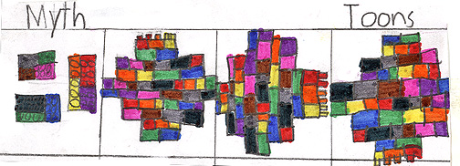
Posted by hooverneb at 11:10 AM 1 comment:
Email ThisBlogThis!Share to TwitterShare to Facebook

Hawaii
It all started when I was waiting in a huge airport for what seemed like hours. Finally, hundreds and hundreds of people slowly pour onto the Hawaiian Airline. I waited for the plane to taxi to the runway. Then, it gets ready for takeoff.
In several mind numbing hours later, the plane began its slow descent. In another hour, it started to land, first the back two wheels, and then the front single wheel.
Now, in a few minutes, I am slowly, making my way down the aisle to the open door with my HUGE snowboard backpack, feeling like I'm snowboard down a slope, but the moment I stepped out the door, I didn't feel like I was snowboarding anymore, I felt like I was sitting down in the sun in Death Vally, when I stepped into Honolulu. I quickly walked onto the Jetway and then, looked at the garden for an hour and then I got onto the next plane that goes to Kona.
It only took thirty minutes to get there. Then I walked along the crooked Jetway to pick up our luggage and then took the Dollar bus to pick up the rental car, which was a silver Jeep.

Posted by hooverneb at 10:26 AM No comments:
Email ThisBlogThis!Share to TwitterShare to Facebook

